

Daysie 🌱

Habit Tracker

**Instructions**

Daysie is a lil habit tracker made to sit on your desk, look cute, and cheer you on every day as you work on your streak of choice. To send updates, open the Daysie app.

Here you will see a pic of daysie, a text field, a date picker, two faces, and a lil tracking calendar.

**Getting Started**

To start tracking a goal habit, first enter the name of the habit you wanna track, e.g. “Do 3000 situps every day!”:

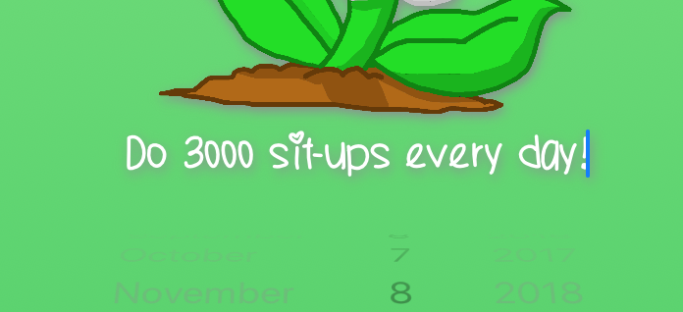

Now you have something to work towards! Each face emoji is a button. Press the button to log a successful day, where you practiced the habit. Otherwise, press the  button to log a day when you could’ve done better.

You can also use the date picker to go back until the beginning of the year to log results from previous days.

**Tracking Streaks**

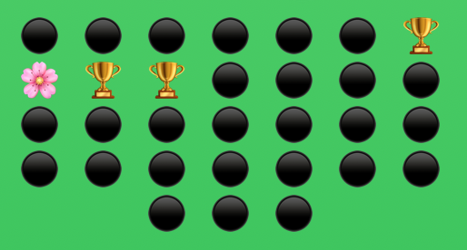

When you press either button, you should see one of the spots on the tracking calendar change. Every spot on the tracking calendar marks a day in the selected month, and every row represents a week-long streak. When you log a successful day, a emoji appears on the corresponding day. If you log otherwise, a will appear.

**Syncing with Daysie**

Once you’ve updated your log, you can sync the data to Daysie over Bluetooth. To sync, tap the picture of the daisy at the top of the screen, then check out Daysie. She should show a loading screen like this:



Then, after a bit, your streak and goal should appear on her screens! Each row of her screen is a week of the current month. A green square indicates a successful day, and yellow shows a day when you could’ve done better.

And that’s it! If you need any help, feel free to contact Gñin any time. Love you, and Merry Christmas!



*The more you praise and celebrate your life, the more there is to celebrate.*

***-Oprah Winfrey***